Opportunities for July

July 4 Happy 4th of July

July 11 2:00 Deacon's Meeting

July 13 6:30 Pat Connelly Missions
July 14 6:15 Business/Prayer Mtg.
July 18 5:30 VBS Kick-Off
July 20 10:30am Daytime wMu Mtg.
July 25-29 Vacation Bible School

Tellers for July

July 6 Julie Ferguson

July 12 Gwen Heape

July 19 Sheron Barnes

July 26 Julie Ferguson

Ushers for July

Ralph DeLoach

Gerald Ulmer

Gerhard Gressman

Deacons on call for July

Chris Mills (June 27-July 3)

Chip Mixon (July 4-10))

Bill Parker (July 11-17)

DeKelly Pittinger (July 18-24)

Greg Ackerman (July 25-31)




Varnville First Baptist Church, Inc.
Last week, Heyward Evans and I were messengers from our respective churches to the Southern Baptist Convention. Before I evaluate this event, I would like to thank the church for sending us. Many ministers unfortunately serve in ministerial contexts where they must incur all their convention expenses as well as use vacation time to attend such a meeting. Your generosity toward Heyward and me will always be greatly appreciated.
However, I must be a good steward of your generosity and report on the events/results of this meeting. While it was refreshing to see many ministerial colleagues, the convention proceedings were tense and foreboding. The resolutions committee refused to acknowledge such needed repentance from abortion. Yet, they quickly dealt with sexual abuse. It seemed that repentance for murder was less needed than sexual misconduct. Since both these sins are heinous, repentance should be equally mandated scripturally.
The convention officers election was also contentious. Four candidates were vying for convention president. After the first ballot, a run-off was necessary between Mike Stone from Georgia and Ed Lister from Alabama. Ed Lister won the run-off by fifty-two percent. However, many messengers were concerned that Dr. Lister will define his presidency by ignoring issues such as critical race theory and intersectionality.
While these terms may seem foreign to the average Southern Baptist, they are important terms that should be defined and studied. Critical race theory states that “racism is engrained in the fabric of our culture” and is based on “white privilege and white supremacy, which perpetuates the marginalization of people of color.” Intersectionality is about “the multiple layers of oppression minorities suffer.” These terms are Neo-Marxists in origin and are instituted to cripple the church’s evangelical mission and further divide the Southern Baptist Convention and the United States.
During the summer, I will be addressing these important issues that face the church, the Southern Baptist Convention and the United States. Please pray as fervently as you know how for the future of our denomination and nation.
In Christ, Tommy

•”Fault Lines: The Social Justice Movement and Evangelicalism’s Looming Catastrophe by Voddie T. Bauchman, Jr. was cited in this article.

Volume 33 Number 7







Vacation Bible School
July 25-29, 2021

Climb aboard for a mountain of
fun at Rocky Railway VBS! A faith-filled adventure where kids discover that trusting Jesus pulls them through life’s ups and downs. Dinner will be served each night.

Don't forget to bring a friend!

5:30-8:30pm



Games...Food...Registration
Fun! Fun! Fun!

Pat Connelly Missions Group
Will meet in the Social Hall
Tuesday, July 13th at 6:30pm

Daytime wMu Group
Will meet in the Family Life Center
Tuesday, July 20th at 10:30am





Please submit your
articles for the August Newsletter
to the church office
no later than Monday, July 19th.



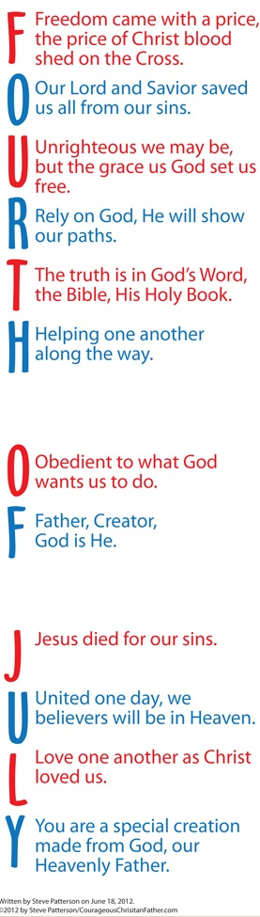
July Birthday's

July 6 Cole Ginn
July 9 Alex Crosby
July 10 Marsha Gray
July 11 Jacob Corley
July 11 Grace DeLoach
July 11 Ali Pittinger
July 11 Mary Lou Troyer
July 12 Ashleigh Avant
July 13 George Padgett
July 14 Michael Eaddy
July 14 Kari McCallister
July 16 Steven Rea
July 18 Maegin DeLoach
July 18 Brant Dobson
July 18 Mariah Kibodeaux
July 19 David Lee
July 19 Trey Mixson
July 19 Colby Sullivan
July 20 Bob Buchanan
July 21 Bradley Owens
July 22 Carol Mixon
July 22 Terry Ulmer
July 23 Margie Corbin
July 24 Karen Harrison
July 26 Noah Alexander
July 26 Howard Black
July 26 Pete Brunson
July 27 Raymond Bennett
July 27 Adam Rea
July 28 Amanda Pittinger
July 29 Rebekah Kelly
July 29 Melissa Polk
July 30 Kristopher Carr
July 31 Marcie Taylor



